Easy Pass

|  |  |
| --- | --- |
| Entities | Object |
| Station | * id: int NOT NULL PK AI * name: varchar(100) * toll: int * address : varchar(100) |
| Owner | * id int NOT NULL PK AI * firstname varchar(10) * last-name varchar(10) * address varchar(100) * phone varchar(15) * email varchar (50) * EasyCard_id int NOT NULL PK FK |
| EasyCard | * id int NOT NULL PK FK * money int NOT NULL |
| Transaction | * id int PK AI * owner _id int NOT NULL FK * amount int * type varchar(10) * total int |
| request | * register * add * pay * checkToll * checkAmount * listAllTransaction |

ER-Diagram

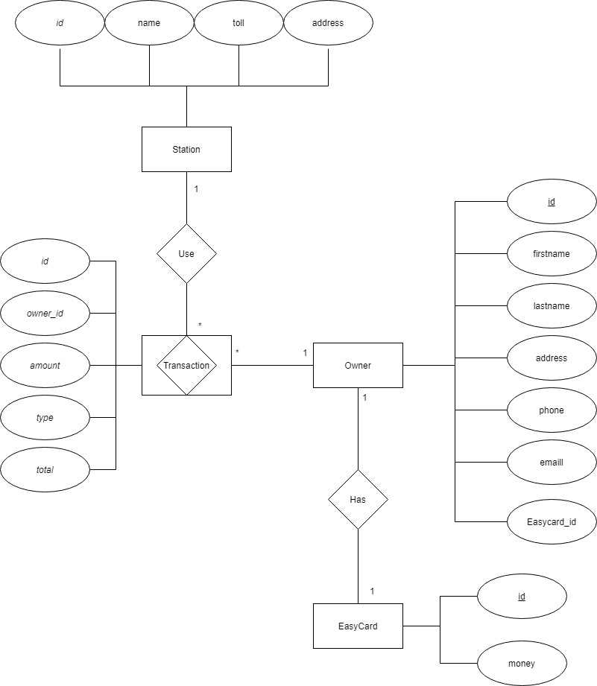

Request

POST /register

Register request body

{

    "firstname": "Kaphon",

    "lastname": "Saengdara",

    "address": "46/98",

    "phone": "0883182660",

    "email": "kaponnon@gmail.com",

    "money": 500

}

PUT /add

Add request body

{

    "id": 1,

    "amount": 300

}

PUT /pay

Pay request body

{

    "id": 1,

    "station_name": "Bangkok"

}

GET /checkToll/?name=Bangkok

GET /checkMoney /?owner_id=1

GET /listTransaction /?owner_id=1

Response

Register response

{

    "statusCode": 200,

    "message": "success",

    "data": {

        "id": 1,

        "firstname": "Kaphon",

        "lastname": "Saengdara",

        "address": "46/98",

        "phone": "0883182660",

        "email": "kaponnon@gmail.com",

        "EasyCard_id": 1

    }

}

Add response

{

    "statusCode": 200,

    "message": "success",

    "data": {

        "id": 2,

        "owner_id": 1,

        "amount": 300,

        "type": "add",

        "total": 800

    }

}

Pay response

{

    "id": 1,

    "station_name": "Bangkok"

}

Check toll response

{

    "statusCode": 200,

    "message": "success",

    "data": [

        {

            "name": "Bangkok",

            "toll": 250,

            "address": "45/56 road"

        }

    ]

}

Check money response

{

    "statusCode": 200,

    "message": "success",

    "data": [

        "You have money = 550"

    ]

}

List transaction response

{

    "statusCode": 200,

    "message": "success",

    "data": [

        {

            "id": 1,

            "owner_id": 1,

            "amount": 500,

            "type": "add",

            "total": 500

        },

        {

            "id": 2,

            "owner_id": 1,

            "amount": 300,

            "type": "add",

            "total": 800

        },

        {

            "id": 3,

            "owner_id": 1,

            "amount": 250,

            "type": "pay",

            "total": 550

        }

    ]

}